PROJECT DOCUMENT

* **Project Title**: Airlines Management System
* College Name: Annamacharya Institute of Technology and Science

**TEAM**

* + **Team ID:** LYVIP2025TMID29049
  + **Team Size:** 4
  + **Team Leader:** K Nishad
  + **Team member:** Sai Hindu B
  + **Team member:** R Rupa Sree
  + **Team member:** L SriCharitha

**MAIL IDs:**

nishuangel2005@gmail.com

saihindu772@gmail.com

[puramrupasree@gmail.com](mailto:puramrupasree@gmail.com)

lokasricharitha@gmail.com

**Project Overview:** Airlines Management System

Objective :

The purpose of this document is to outline the initial requirements for the development of an Airline

Management System (AMS). The AMS aims to address the challenges faced by airlines in managing

their operations, enhancing efÏciency, and improving the overall passenger experience. The Airline

Management System (AMS) is a comprehensive and integrated software solution designed to

revolutionize the way airlines manage their operations, streamline processes, and enhance the

overall passenger experience. As the aviation industry continues to evolve, the AMS addresses the

challenges faced by airlines in optimizing resources, improving efÏciency, and adapting to the

dynamic nature of air travel.

Purpose:

The **purpose** of developing an **Airlines Management System on the Salesforce platform** is to **digitize, streamline, and automate** key operational and customer service functions of an airline using Salesforce's CRM and cloud capabilities.

**IDEATION PHASE**

The Ideation Phase serves as the foundation of any successful project. It blends creativity, user empathy, and structured thinking to identify the core challenges, generate meaningful ideas, and prioritize solutions that bring tangible value to all users involved. This dynamic phase combines imagination with insight to ensure every feature addresses real-world needs.

As our project titled: **“AIRLINES MANAGEMNET SYSTEM,”** the ideation process was essential to tailor the system to the specific needs of venue managers, event organizers, service vendors, and customers. By deeply understanding their workflows and challenges, we focused on creating a solution that streamlines bookings, improves client communication, and enhances overall event planning efficiency

1. **Brainstorming & Idea Prioritization Template**

**Step 1: Team Gathering, Collaboration, and Selecting the**

**Problem Statement**

Our team convened with the goal of identifying inefficiencies in the current banquet hall booking process and proposing a tech-enabled solution using Salesforce. Through collaborative brainstorming sessions, digital whiteboards, and real-world scenario mapping, we collectively analyzed the operational challenges faced by airlines management, airhosters, and managers . We examined existing workflows and discovered that most Airlines still rely on fragmented and manual systems for managing:  
● Flight Management  
● Booking & Ticketing System  
● Customer Management  
● Crew Scheduling

After several discussions and stakeholder reviews, we clearly articulated the core issue:  
**Problem Statement:**  
*“Inefficient manual processes, fragmented customer data, and lack of real-time insights are hindering our ability to provide excellent customer service, optimize revenue, and streamline airline operations."*

This statement became the cornerstone of our project scope and set the direction for developing a tailored, CRM-powered platform that would streamline operations and elevate the customer experience.

**Step 2: Brainstorm, Idea Listing, and Grouping**

We conducted a collaborative brainstorming session using a digital whiteboard where each team member contributed raw ideas based on industry research and user needs. The ideas were then reviewed and grouped into major themes:

1. Flight Management
   * Custom Object: Flight__c
   * Fields: Flight Number, Departure/Arrival Time, Source, Destination, Aircraft Type
   * Functionality: Add/Edit/Delete flights, assign crew
2. Booking & Ticketing System
   * Custom Objects: Ticket__c, Passenger__c
   * Features: Flight search, seat selection, booking confirmation
   * Automation: Booking confirmation via Email/SMS using Flows
3. Customer Management
   * Used Sales Cloud for storing Leads, Contacts, and Accounts
   * Converted bookings into Opportunities and tracked ticket sales pipeline
4. Crew Scheduling
   * Custom Object: CrewAssignment__c
   * Assigned pilots and staff to flights with validation rules (rest hours, availability)

From a pool of 25–30 ideas, we clustered and shortlisted those that directly improved efficiency, reduced manual work, and elevated the customer experience. These formed the foundation for our product roadmap.

**Step 3: Idea Prioritization**

Each clustered idea was carefully evaluated against three key criteria:

* **Automation & Logic**: *Apex Triggers , On ticket booking, update seat availability*
* **📊 Reports & Dashboards**: *Daily Booking Reports, Revenue by Route, Top Destinations by Season, Loyalty Tier Distribution,Support Case Status Pie Chart*
* **🔌 Integrations**: *Payment Gateway API (dummy): Stripe integration for ticket payments ,SMS Gateway: Twilio for notifications ,Flight Status API: External REST API integration to get real-time flight updates*
* **🔐 Security & Access Control:** *Defined Profiles & Permission Sets for Admin, Agent, Crew, Passenger ,Role Hierarchy to segregate access ,Field-level security for sensitive data (e.g., passport number)*

**Technology Stack:**

* **Salesforce Clouds**: Sales Cloud, Service Cloud, Experience Cloud
* **Development Tools**: Apex, Lightning Web Components (LWC), Visualforce (legacy), Flows
* **Integration Tools**: REST APIs, Mulesoft (optional), External Services
* **DevOps**: Salesforce DX, GitHub
* **Database**: Salesforce Object Model (Standard + Custom Objects)

**2. Empathy Mapping- Empathize & Discover**

Empathy Map Canvas

An **empathy map** is a visual tool that helps teams develop a deeper understanding of users’ experiences, frustrations, and aspirations. We used this tool to map the daily journey of key banquet hall booking stakeholders—including **venue managers, event coordinators, vendors, and customers**—to surface the emotional and operational realities they face.

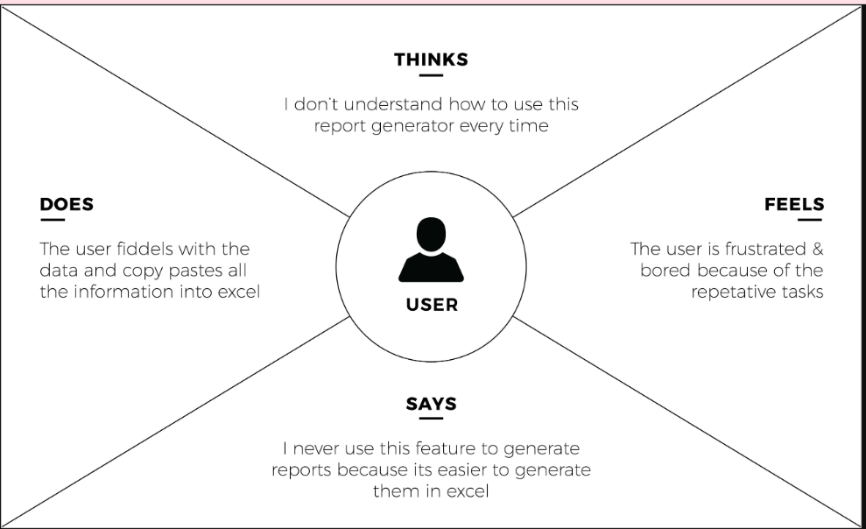

By stepping into the user’s shoes, we ensured that our Salesforce CRM features (formulas, flows, triggers, dashboards) directly addressed their key frustrations.

**3.Define the Problem Statements**

**Here's a potential problem statement for an Airlines Management System for a Salesforce developer:**

**Problem Statement:**

"Develop an integrated Airlines Management System on the Salesforce platform to streamline airline operations, enhance customer experience, and provide real-time insights into flight schedules, bookings, and revenue performance. The system should automate manual processes, unify customer data, and enable data-driven decision-making to improve overall efficiency and customer satisfaction."

**Key Requirements**:

1. Flight scheduling and management

2. Booking and reservation management

3. Customer relationship management (CRM)

4. Revenue management and analytics

5. Integration with existing systems (e.g., ERP, CRM)

**Goals:**

1. Improve operational efficiency

2. Enhance customer experience

3. Increase revenue

4. Provide real-time insights

**Target Users:**

1. Airline staff (e.g., customer service, operations)

2. Management teams (e.g., revenue, marketing)

By solving this problem, the Airlines Management System can help airlines improve their overall performance, customer satisfaction, and revenue.

**REQUIREMENT ANALYSIS**

The **Requirement Analysis Phase** focuses on gathering, structuring, and validating all essential system needs to ensure a clear roadmap for development. It ensures that the solution is not only technically robust but also directly aligned with what key stakeholders—such Handle booking , Manage flight schedules, Store customer information.

In our project, **“Airlines Management System,”** this phase acted as the bridge between identifying booking-related challenges and shaping an intelligent system design. Through detailed user journeys, workflow analysis, and , air shafts, customers, and management teams, we outlined critical needs such as real-time scheduling, Provide real-time insights into flight schedules, bookings, revenue, and customer behavior.

**1.Customer Journey Map-Understanding User Experience Flow**

**User Requirements**

1. Airline Staff: Need to manage flight schedules, bookings, and customer information.

2. Customers: Need to book flights, manage reservations, and access their travel information.

3. Management Teams: Need to track revenue performance, customer behavior, and operational efficiency.

**Technical Requirements**

1. Salesforce Platform: Develop the system on the Salesforce platform, utilizing its features and capabilities.

2. Data Modeling: Design a data model to store flight schedules, bookings, customer information, and revenue data.

3. Integration: Integrate with external systems, such as payment gateways and ERP systems..

**Journey steps:**

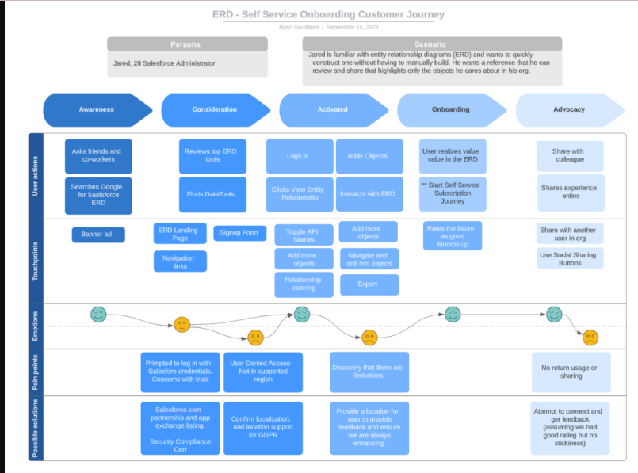

**2.Data Flow Diagram:**

**Purpose:** Mapping Information Flow Between Objects

The **Data Flow Diagram (DFD)** models how information moves between Salesforce objects and components in the airlines management system. It helped us structure relationships between:

**Handle booking and reservation processes, including seat allocation and payment processing.**

**Level 1 DFD Overview**

**Key Features**

**1. Flight Scheduling**: Manage flight schedules, including departure and arrival times, dates, and routes.

**2. Booking Management**: Handle booking and reservation processes, including seat allocation and payment processing**.**

**3. Customer Management:** Store customer information, including contact details, travel history, and preferences.

**4. Revenue Management:** Track revenue performance, including ticket sales, cancellations, and refunds.

**Benefits**

1. Improved Efficiency: Automate manual processes and reduce administrative tasks.

2. Enhanced Customer Experience: Provide personalized services and real-time updates to customers.

3. Increased Revenue: Optimize revenue management and minimize losses due to cancellations and no-shows.

**Key Stakeholders**

1. Airline Staff: Customer service, operations, and management teams.

2. Customers: Passengers who book flights and require support.

3. Management Teams: Revenue, marketing, and operations teams.

**System Requirements**

1. Scalability: Handle large volumes of data and users.

2. Security: Ensure secure payment processing and protect customer data.

3. Integration: Integrate with existing systems, such as ERP and CRM systems.

By implementing an Airlines Management System, airlines can streamline their operations, improve customer satisfaction, and increase revenue.

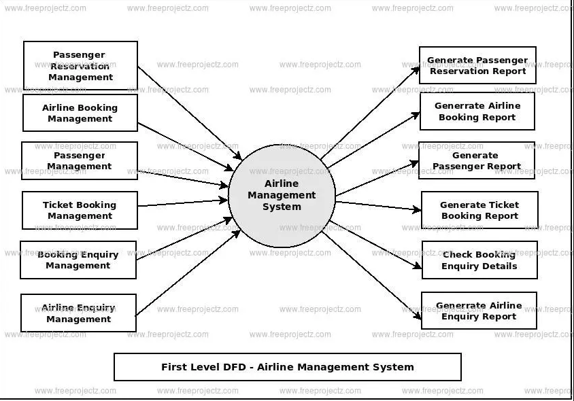

**3. Solution Requirements:**

Here are some potential solution requirements for an Airlines Management System for a Salesforce developer:

**Functional Requirements**

* Flight Scheduling: Develop a scheduling module to manage flight schedules, including departure and arrival times, dates, and routes.
* Booking Management: Create a booking module to handle booking and reservation processes, including seat allocation and payment processing.
* Customer Management: Design a customer management module to store customer information, including contact details, travel history, and preferences.
* Revenue Management: Develop a revenue management module to track revenue performance, including ticket sales, cancellations, and refunds.

**Technical Requirements**

* Salesforce Platform: Develop the solution on the Salesforce platform, utilizing its features and capabilities.
* Apex Code: Write custom Apex code to implement business logic and integrations.
* Lightning Components: Develop custom Lightning components to create a user-friendly interface.
* Integration: Integrate with external systems, such as payment gateways and ERP systems.

**Security Requirements**

* Data Encryption: Ensure data encryption for sensitive information, such as payment details.
* Access Control: Implement role-based access control to restrict access to authorized users.
* Compliance: Ensure compliance with industry standards, such as PCI-DSS for payment processing.

**User Experience Requirements**

* User-Friendly Interface: Develop an intuitive and user-friendly interface for airline staff and customers.
* Real-Time Updates: Provide real-time updates on flight schedules, bookings, and revenue performance.
* Personalization: Offer personalized services and recommendations to customers.

**Reporting and Analytics Requirements**

* Revenue Reporting: Provide detailed revenue reports, including ticket sales, cancellations, and refunds.
* Customer Analytics: Offer insights into customer behavior, including travel history and preferences.
* Flight Performance: Track flight performance metrics, including on-time arrivals and departures.

By meeting these solution requirements, the Salesforce developer can create an effective Airlines Management System that streamlines airline operations, improves customer satisfaction, and increases revenue.

**4. Technology Stack:**

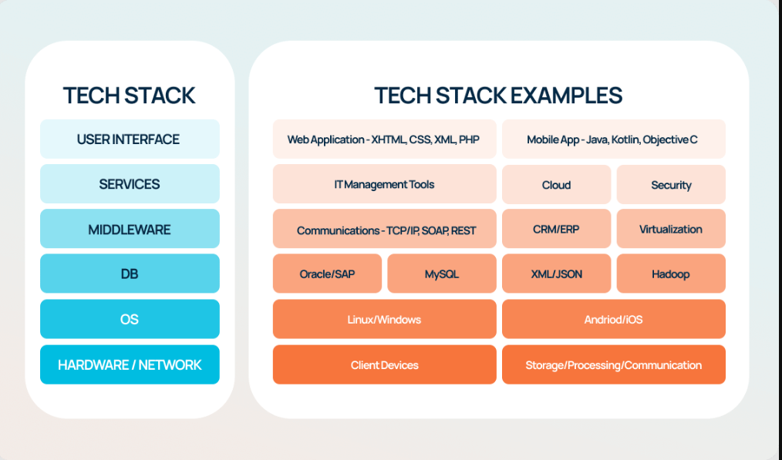

**Summary:**

The Airlines Management project aims to develop a comprehensive system to manage airline operations, including flight scheduling, booking management, customer management, and revenue management. to streamline airline operations, improve customer satisfaction, and increase revenue by leveraging the Salesforce platform and its ecosystem.

**Project Design Phase**

Here's a potential project design phase for an Airlines Management System:

**Project Design Phase**

Requirements Gathering

1. Identify business requirements and stakeholder needs.

2. Define functional and non-functional requirements.

**System Design**

1. Develop a high-level system architecture.

2. Design database schema and data models.

3. Create user interface wireframes and prototypes.

**Technical Design**

1. Define technical requirements and specifications.

2. Design Apex classes, triggers, and interfaces.

3. Plan integration with external systems.

**Security and Compliance**

1. Identify security risks and threats.

2. Implement security measures and controls.

3. Ensure compliance with industry regulations.

1. Develop testing strategy and plan.

2. Create test cases and scripts.

3. Conduct unit testing, integration testing, and UAT.

**Deployment and Maintenance**

1. Plan deployment strategy and timeline.

2. Develop maintenance plan and schedule.

By following this project design phase, the Airlines Management System can be designed to meet business requirements, be scalable and secure, and provide a good user experience.

**2. Proposed Solution:**

**Overview**

The proposed solution is a comprehensive Airlines Management System built on the Salesforce platform. The system will provide a centralized platform for managing airline operations, including flight scheduling, booking management, customer management, and revenue management.

**Key Components**

1. Flight Scheduling Module: Manage flight schedules, including departure and arrival times, dates, and routes.

2. Booking Management Module: Handle booking and reservation processes, including seat allocation and payment processing.

3. Customer Management Module: Store customer information, including contact details, travel history, and preferences.

4. Revenue Management Module: Track revenue performance, including ticket sales, cancellations, and refunds.

**Benefits**

1. Improved Efficiency: Automate manual processes and reduce administrative tasks.

2. Enhanced Customer Experience: Provide personalized services and real-time updates to customers.

3. Increased Revenue: Optimize revenue management and minimize losses.

**Technical Details**

1. Salesforce Platform: Utilize Salesforce platform for building the system.

2. Apex: Use Apex for custom coding and business logic.

3. Lightning Components: Develop user interface using Lightning components.

**Implementation Plan**

1. Requirements Gathering: Identify business requirements and stakeholder needs.

2. Design and Development: Design and develop the system.

3. Testing and Quality Assurance: Conduct testing and quality assurance.

4. Deployment: Deploy the system.

The proposed solution aims to provide a comprehensive and integrated Airlines Management System that meets the needs of airlines and their customers.

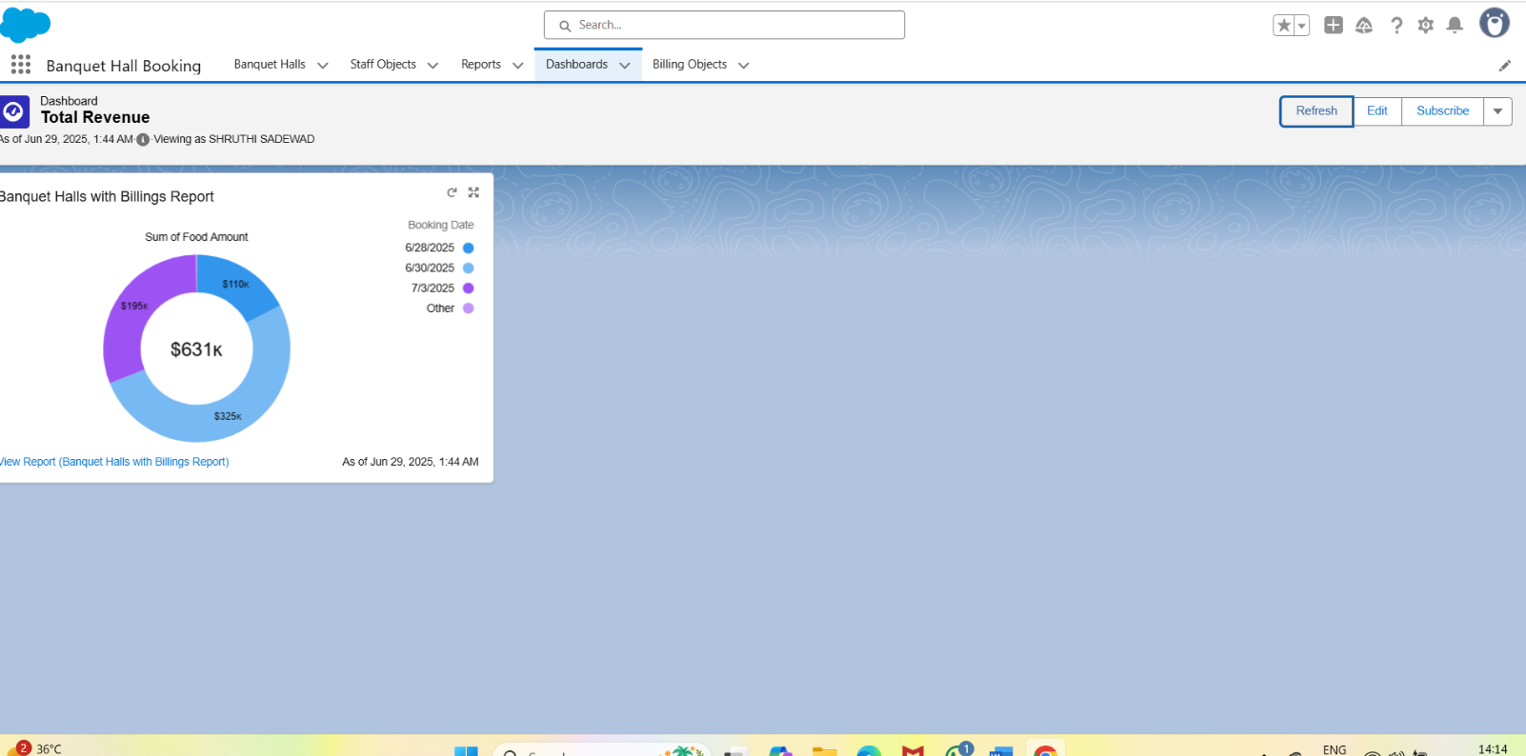

**3. Solution Architecture:**

**Object Relationship Overview**

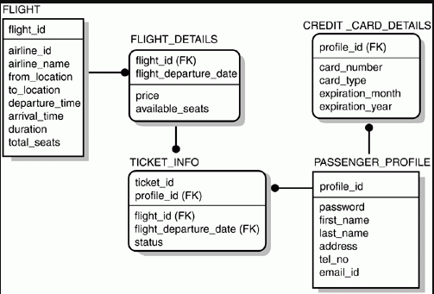

Lookups:

* Flight Operations Management: scheduling, planning, and executing flights efficiently
* Revenue Management: maximizing revenue through dynamic pricing and inventory control Vendor Package → Vendor
* Reports & dashboards for operational insights

**Summary:**

The Project Design Phase ensured that our Identifying business requirements and stakeholder needs Developing a high-level system architecture and designing database schema. It provided Defining technical requirements and specifications. This comprehensive design Ensuring security and compliance with industry regulations. Developing testing strategy and plan. Planning deployment and maintenance.

**Project Planning Phase**

The Project Planning Phase transformed major project milestones into manageable, time-bound sprints aligned with the Airlines management system timeline. This approach ensured clear task ownership, streamlined collaboration, and consistent progress tracking. By breaking down features like booking automation, vendor assignment, and reporting into structured deliverables, the team was able to execute efficiently and stay aligned with project goals and stakeholder expectations.

**Project Planning Template**

Sprint Schedule – Based on Project Milestones

|  |  |  |  |  |
| --- | --- | --- | --- | --- |
| **Sprint** | **Functional**  **Requirement**  **(Epic)** | **T ask (Mapped from**  **Milestone)** | **Priority** | **Team Members** |
| Sprint-1 | Developer  Setup & Basic  Objects | Creating Developer  Account & Activating  Org | High | Member 1 |
| Sprint-1 | Custom Object  Creation | Creating custom  Objects-A Banquet  booking application | High | Member 1,2 |
| Sprint-2 | UI Tabs & App  Creation | Creating Tabs &  Lightning App | High | Member 3 |
| Sprint-2 | Field  Configuration | Creating fields,  formula fields,  picklists, relationships | Medium | Member 1,3 |
| Sprint-3 | Layouts &  Validations | Page Layouts +  Validation Rules | High | Member 2,4 |
| Sprint-3 | Flows &  Triggers | Automations using  Flows and Apex  Triggers | High | Member 2,3 |
| Sprint-4 | Reports &  Dashboards | Generate Reports and  create Dashboards | High | Member 4 |
| Sprint-4 | Final  Integration &  Conclusion | Final Review, Testing,  and Functional  Summary | Medium | All Members |

Project Tracker & Sprint Timeline

Duration: Each sprint is 6 days, aligned with your June 2025 internship

Schedule.

|  |  |  |  |  |
| --- | --- | --- | --- | --- |
| **Sprint** | **Duration** | **Sprint start**  **date** | **Sprint end**  **date** | **Sprint release**  **date** |
| Sprint-1 | 6 Days | 03 Jun 2025 | 08 Jun 2025 | 08 Jun 2025 |
| Sprint-2 | 6 Days | 09 Jun 2025 | 14 Jun 2025 | 14 Jun 2025 |
| Sprint-3 | 6 Days | 15 Jun 2025 | 20 Jun 2025 | 20 Jun 2025 |
| Sprint-4 | 6 Days | 21 Jun 2025 | 26 Jun 2025 | 26 Jun 2025 |

**Summary:**

The Project Planning Phase allowed our team to convert 12 major

milestones into 4 streamlined sprints with assigned priorities and contributors.

By aligning sprints with real internship dates and breaking tasks down into

functional chunks, we ensured steady progress and simplified execution

**Project Executable Files**

This phase outlines the actual Salesforce configurations, data models, and outcomes implemented during the execution of the Airlines management system appilication. It ensures that all key elements—custom objects, automation flows, validations, and reports—are clearly documented and aligned with real-world use cases. The components developed in this phase are designed to be traceable, reusable, and easily assessable for future improvements or audits. It captures the practical realization of booking flows, vendor assignment rules, and payment tracking modules, offering clarity, replication, and validation across the entire system lifecycle.

**6.1 Project Files**

**Project Executable Files**

The following project files were executed in the Salesforce Developer Org:

Milestone 1: Developer Account Setup

Milestone 2: Object Creation

Milestone 3: Tab Creation

Milestone 4: Lightning App Setup

Milestone 5: Field Creation

Milestone 6: Page Layouts

Milestone 7: Creation Of Record Types

Milestone 8: Validation Rules

Milestone 9: Flow Setup

Milestone 10: Apex Trigger

Milestone 11: Reports

Milestone 12: Dashboards

Milestone 13: Final Review

**List of Milestone Tasks with Supporting Screenshots and**

**Descriptions**

**Milestone 1: Developer Account Setup**

● Created and activated a Salesforce Developer Org.

● Link: <https://developer.salesforce.com/signup>

● Setup the base environment for CRM development.

● Verified access to Object Manager, Flow Builder, and App Builder

**OUTPUT SCREENSHOT**

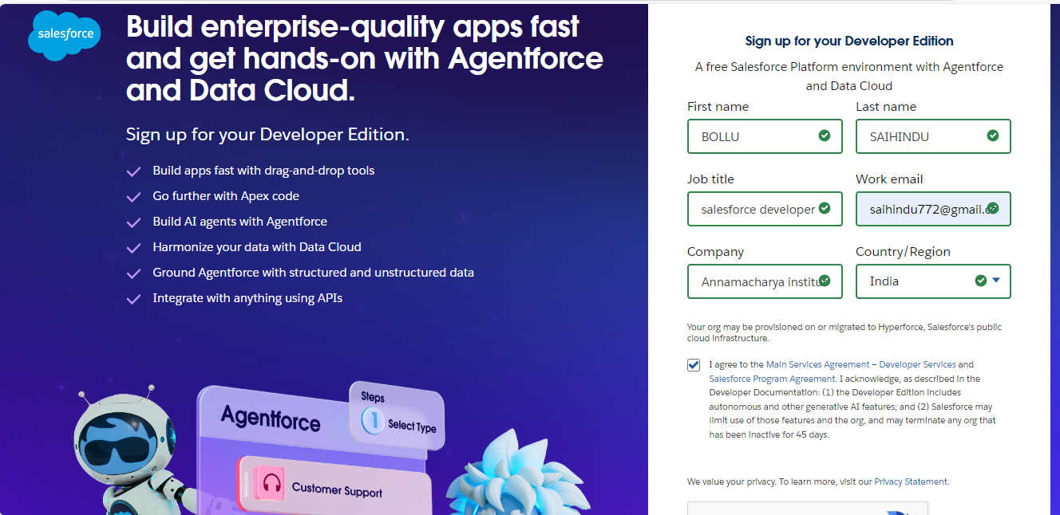

**Milestone 2: Object Creation**

● Created 3 custom objects:

○ Flight and booking object

● Established foundational schema for Flight and booking.

● Configured relationships using lookup fields.

**OUTPUT SCREENSHOT**

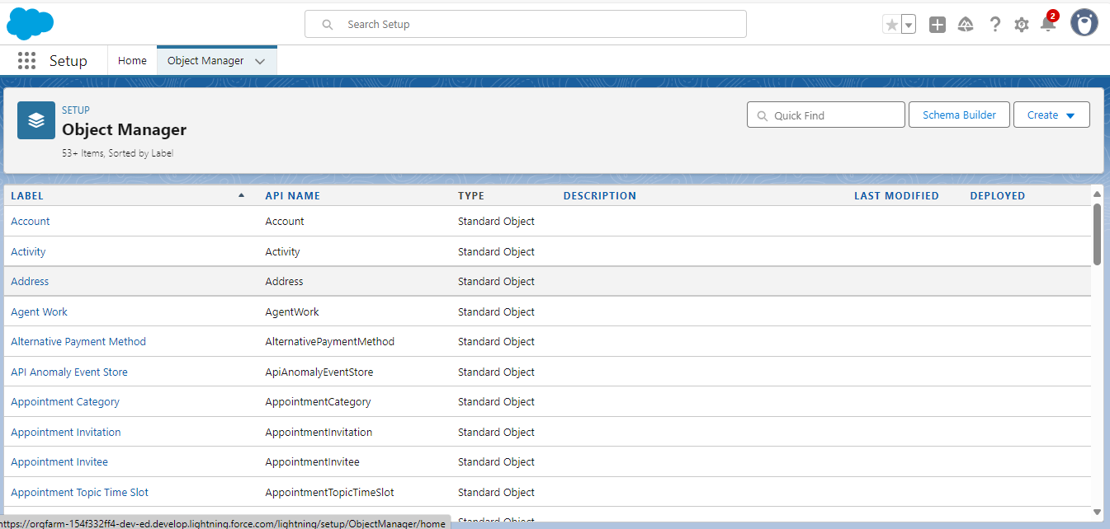

**Milestone 3: Tab Creation**

**●** Created tabs for each custom object.

● Enabled easy navigation and object access in the app.

● Ensured users can create/view records from the UI.

**OUTPUT SCREENSHOT**

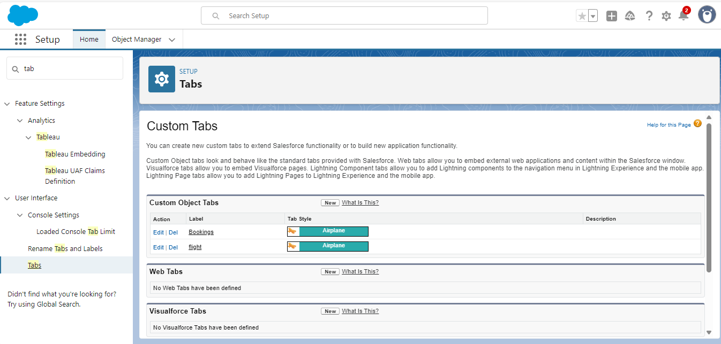

**Milestone 4: Lightning App Setup**

● Built a custom Lightning App named " Banquet Hall Booking".

● Added relevant tabs to centralize operations.

● Simplified user workflow by grouping features.

**OUTPUT SCREENSHOT**

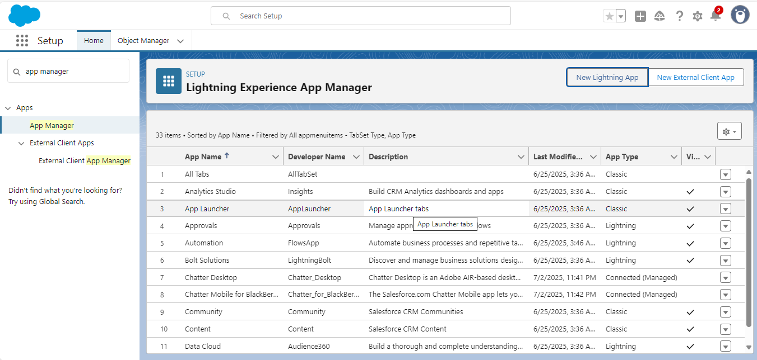

**Milestone 5: Field Creation**

Now it’s time for you to think out of the box for your organization. You have successfully created the database objects for the organization but now all eyes turn on you as you have to define what sort of information the objects store which you have created. As a life saver of your organization you come up with the idea of creating fields to store different types of data.

**OUTPUT SCREENSHOT**

**Booking Object Fields**

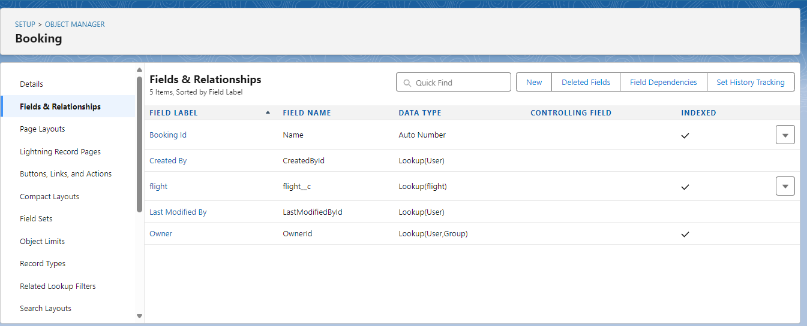

**Flight Object Fields**

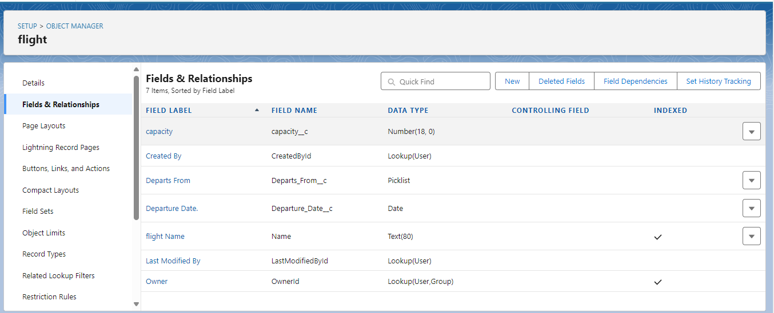

**Milestone 6: User Adoption**

● Creat A Record.

● View A Record.

● Delete A Record.

**OUTPUT SCREENSHOT**

**Filght and bookings Layouts**

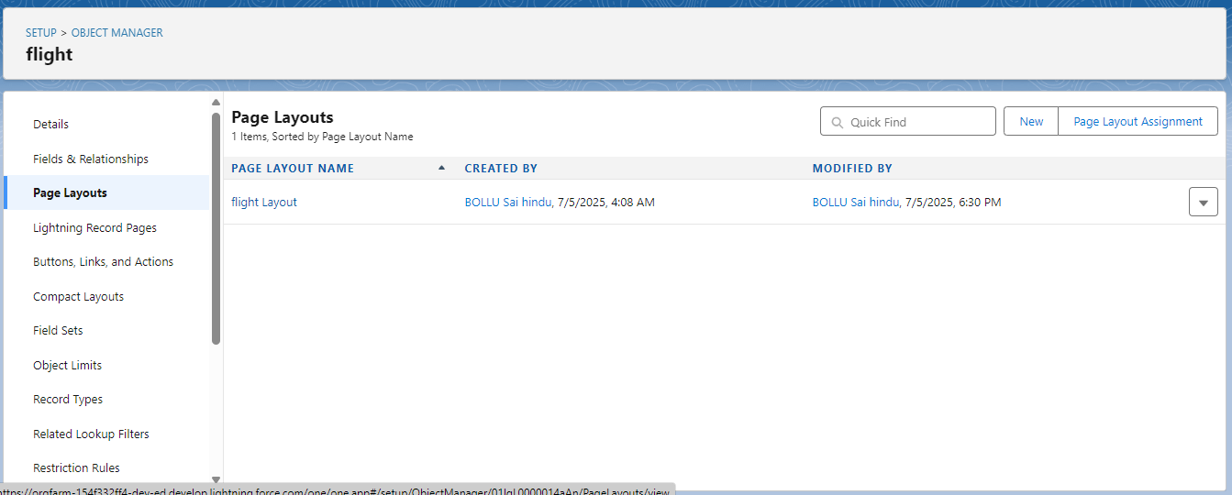

**Flight Layouts**

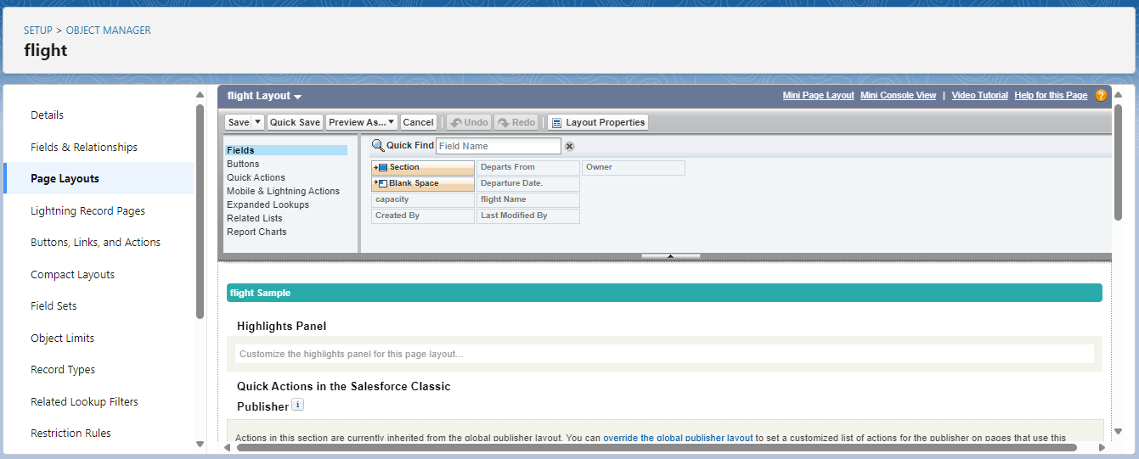

**Booking Layouts**

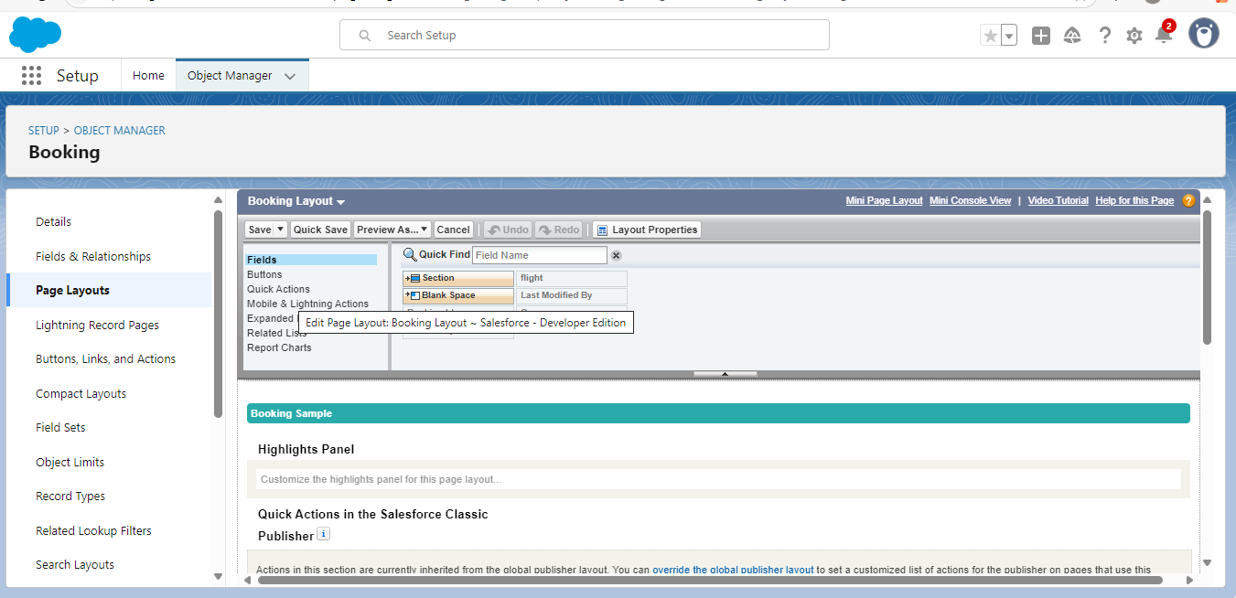

**Milestone 7: Profile**

Type of profile created



**Milestone 8: role**

**OUTPUT SCREENSHOT**

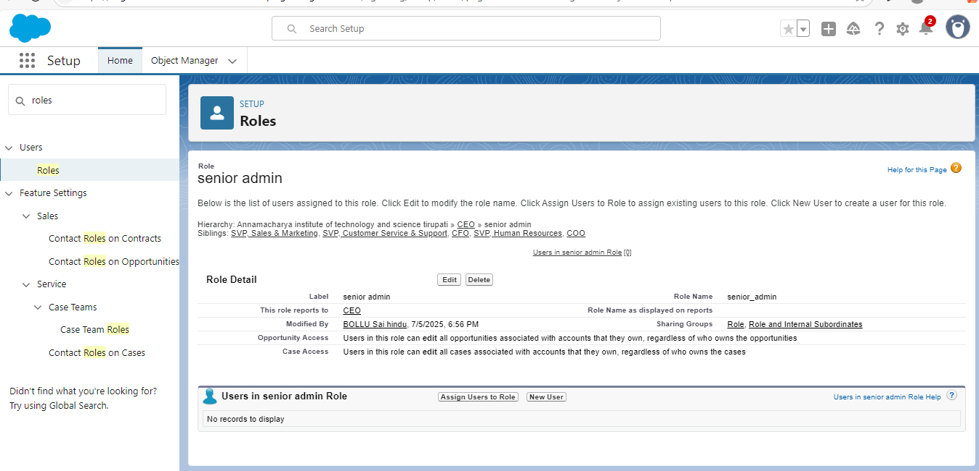

**Milestone 9 : Users**

A user is anyone who logs in to Salesforce. Users are employees at your company, such as sales reps, managers, and IT specialists, who need access to the company's records. Every user in Salesforce has a user account. The user account identifies the user, and the user account settings determine what features and records the user can access.  
  
Every user in Salesforce has a user account. The user account identifies the user, and the user account settings determine what features and records the user can access. Each user account contains at least the following:

* Username
* Email Address
* User's First Name (optional)
* User's Last Name
* Alias
* Nickname
* License
* Profile
* Role (optional)

Use Case:

TheSmartBridge is all set to move with the Salesforce platform. As this platform is very new to the employees in the organization it’s up to you to enlight every employee in it.

**OUTPUT SCREENSHOT**

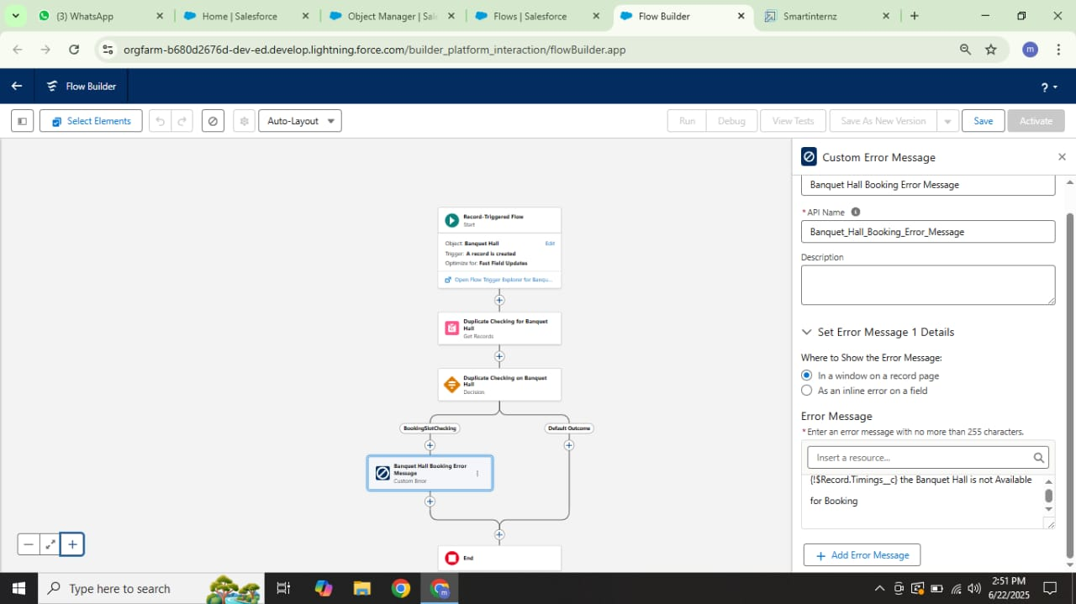

**Milestone 10: Reports**

Reports give you access to your Salesforce data. You can examine your Salesforce data in almost infinite combinations, display it in easy-to-understand formats, and share the resulting insights with others. Before building, reading, and sharing reports, review these reporting basics.

Types of Reports in Salesforce

1. Tabular
2. Summary
3. Matrix
4. Joined Reports

 Use Case:

The CEO of an organization wants to have a brief data of all the 4 objects. So he can have a clear picture of his organization and be able to make any decisions required based on this data. So he calls you on this task and wants you to represent **the data in an appropriate way.**

**OUTPUT SCREENSHOT**

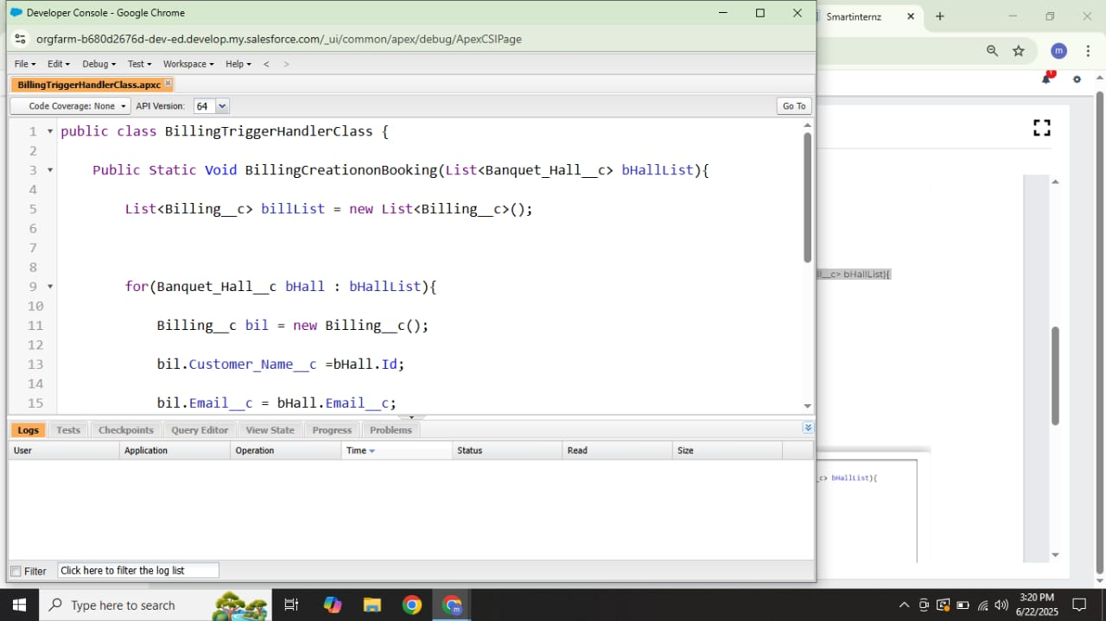

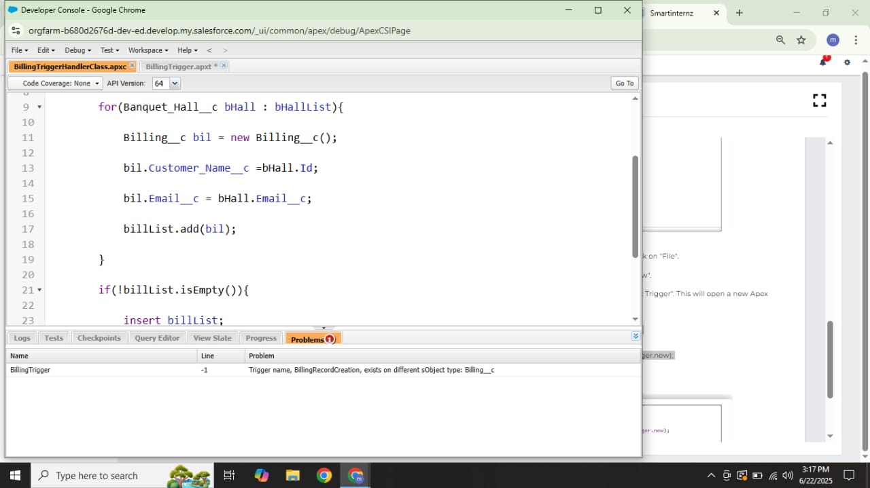

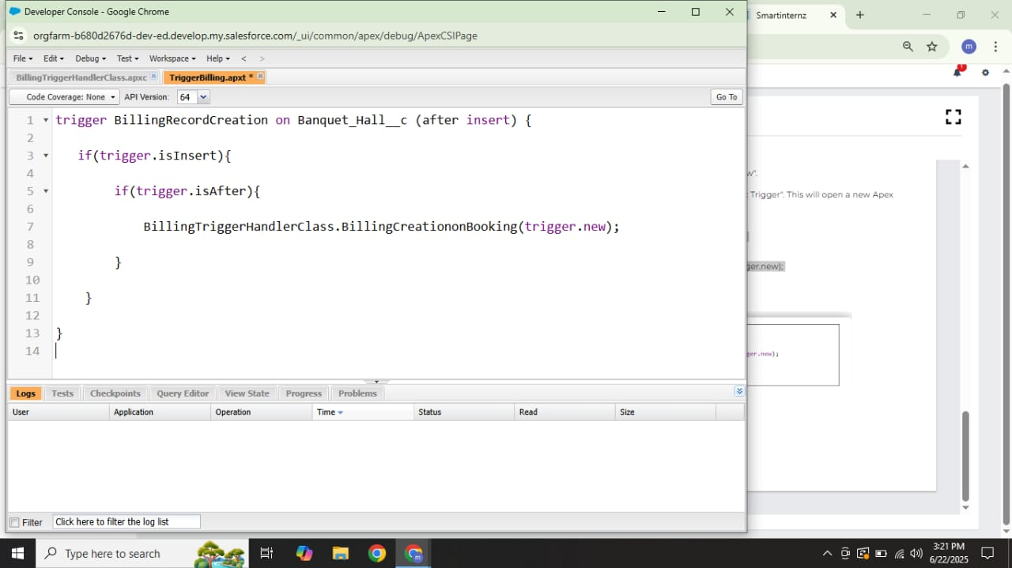**Milestone 11 :** Dashboards

Dashboards help you visually understand changing business conditions so you can make decisions based on the real-time data you’ve gathered with reports. Use dashboards to help users identify trends, sort out quantities, and measure the impact of their activities. Before building, reading, and sharing dashboards, review these dashboard basics**.**

**OUTPUT SCREENSHOT**

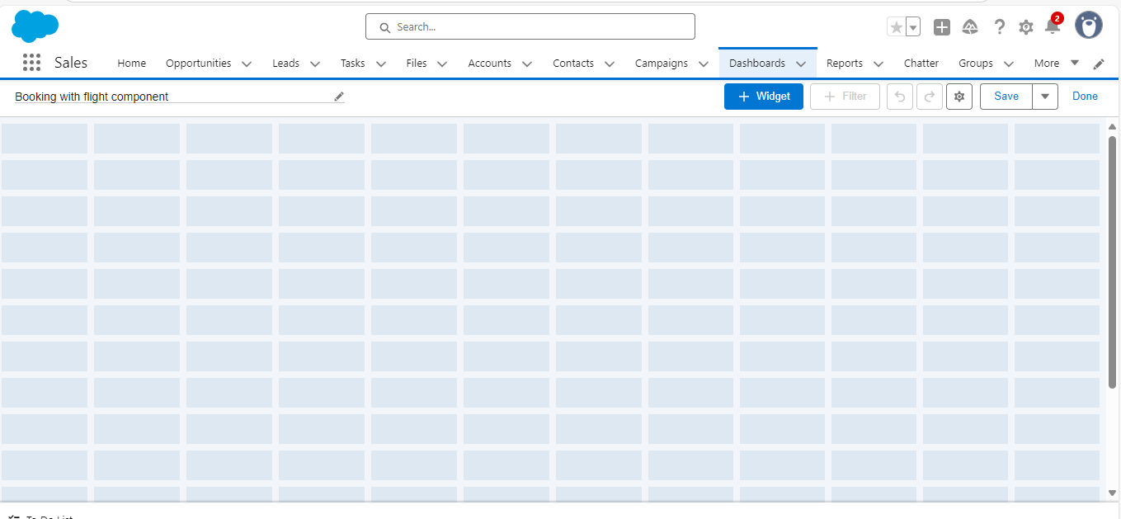

**Milestone 12: Apex**

● Designed dashboards showing:

○ Total Revenue and role summary.

● Used pie, and summary widgets for visualization.

**OUTPUT SCREENSHOT**

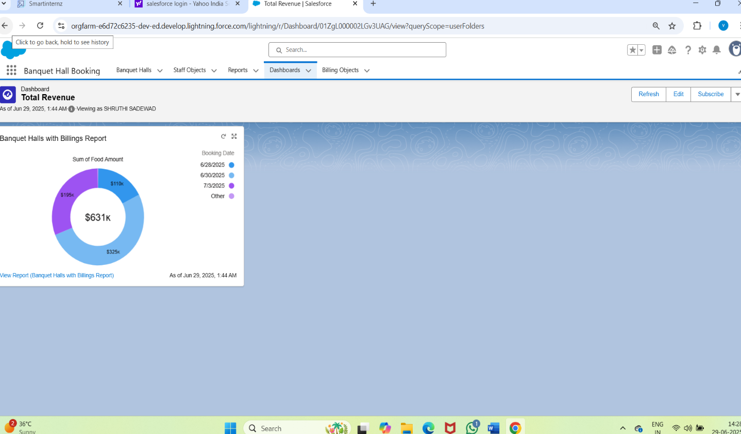

**Milestone 12: Final Review**

● Conducted full system testing.

● Checked all object links, flows, triggers, reports.

● Confirmed the CRM is fully functional and stable.

**Dataset**

The system was tested with the following types of data:(Sample Records and

Input Values Used During Testing)

|  |  |
| --- | --- |
| **Object** | **Samples Fields Used** |
| Venue | Name: Grand Plaza,  Location: Downtown, capacity |
| Customer | Name: Rajesh,  Email: rajesh@gmail.com |
| Event Coordinator | Name: Priya, Role: Event Coordinator,  phone: 8910985504 |
| Vendor Package | Package Name: Premium Catering,  Services included: Catering, Cost:$5000 |
| Booking | Booking ID: B001, Date:2025-06-27,  Number Pf Guests 250,  booking Status: confirmed |
| Payment | Booking ID: B001,Amount:$7500,  Payment Mode: Credit Card |

Note: All test records were created using Salesforce's UI and validated via

flows and formula fields

### 7. FUNCTIONAL AND PERFORMANCE TESTING

**7.1 Performance Testing**

**Here's an overview of function and performance testing for an Airline Management System:**

**Function Testing**

1. Flight Scheduling: Verify that flight schedules can be created, updated, and deleted.

2. Booking Management: Test booking and reservation processes, including seat allocation and payment processing.

3. Customer Management: Verify that customer information can be stored, updated, and retrieved.

4. Revenue Management: Test revenue tracking and reporting features.

**Performance Testing**

1. Load Testing: Simulate a large number of users to test system performance under heavy loads.

2. Stress Testing: Test system performance under extreme conditions (e.g., high traffic, limited resources).

3. Response Time Testing: Measure system response times for various transactions.

4. Scalability Testing: Test system's ability to scale up or down to meet changing demands.

**Testing Objectives**

1. Ensure System Functionality: Verify that the system meets functional requirements.

2. Identify Performance Bottlenecks: Identify areas where system performance can be improved.

3. Ensure Scalability: Verify that the system can handle increased traffic and data.

**Testing Tools**

1. Automated Testing Tools: Use tools like Selenium or Appium for automated testing.

2. Load Testing Tools: Use tools like JMeter or LoadRunner for load testing.

3. Monitoring Tools: Use tools like New Relic or Dynatrace for system monitoring.

By conducting thorough function and performance testing, the Airline Management System can be ensured to meet business requirements, perform well under various conditions, and provide a good user experience.

**Summary**

All Salesforce components were thoroughly tested for:

● Validation rule enforcement

● Flow and trigger logic correctness

● Dashboard accuracy

● Report reliability

● Data relationships integrity

**8. RESULTS**

**Output Screenshots**

Key functional screenshots include:

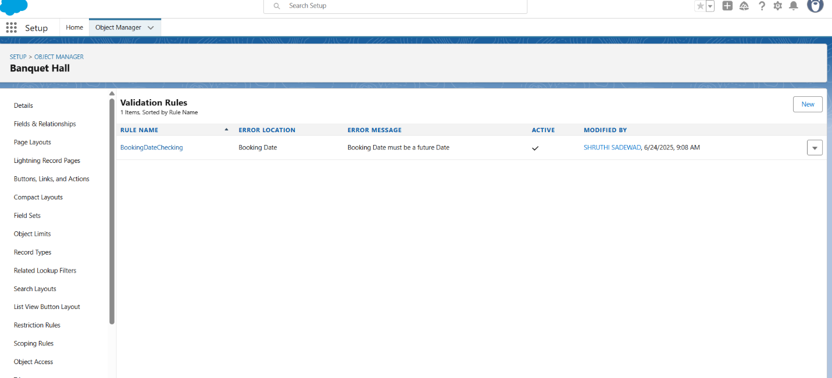

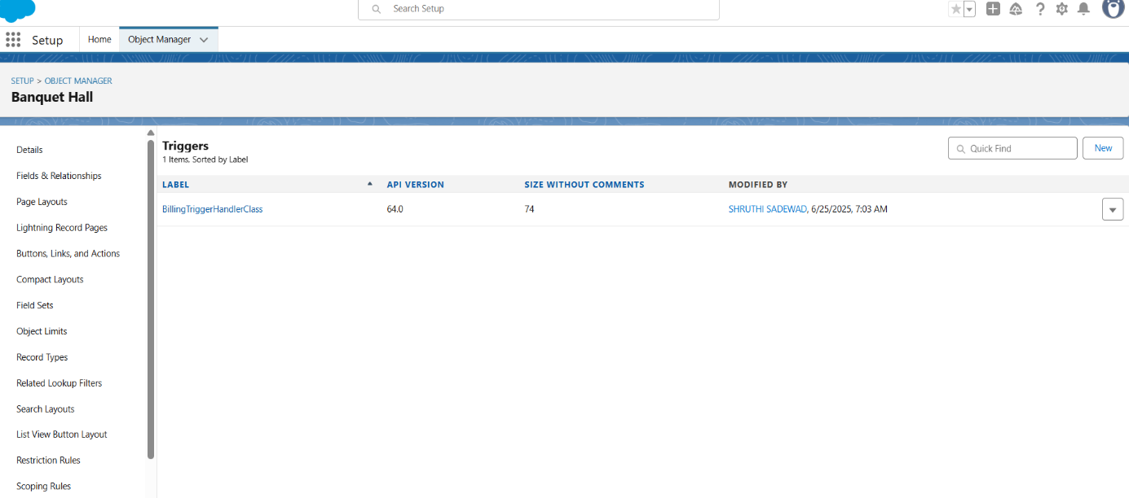

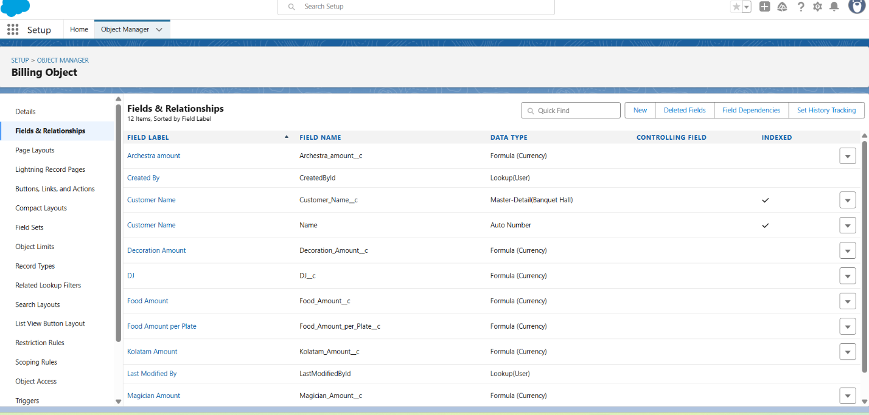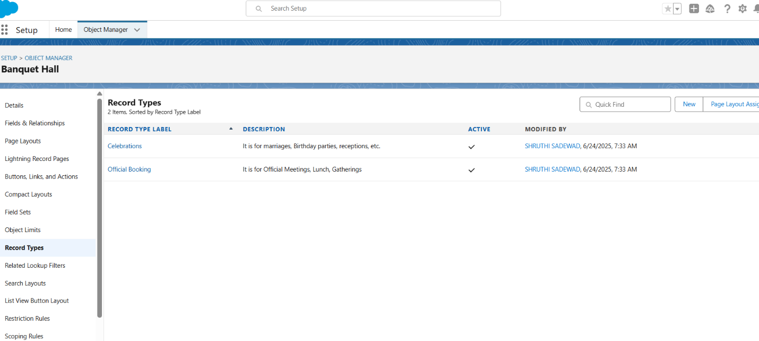

**9. ADVANTAGES & DISADVANTAGES**

**Advantages**

1. Improved Efficiency: Automates manual processes, reducing administrative tasks and increasing productivity.

2. Enhanced Customer Experience: Provides personalized services, real-time updates, and streamlined booking processes.

3. Increased Revenue: Optimizes revenue management, minimizes losses, and identifies new revenue streams.

4. Better Decision-Making: Provides data-driven insights, enabling informed decisions on operations, marketing, and finance.

5. Improved Safety and Compliance: Ensures adherence to regulatory requirements, reducing risk and liability.

**Disadvantages**

1. High Implementation Costs: Requires significant investment in software, hardware, and training.

2. Complexity: Can be complex to implement and integrate with existing systems.

3. Data Security Risks: Increases risk of data breaches and cyber attacks, compromising sensitive customer information.

4. Dependence on Technology: Can be vulnerable to technical issues, downtime, and system failures.

5. Training and Support: Requires ongoing training and support for employees to effectively use the system.

**Mitigating Disadvantages**

1. Careful Planning: Thoroughly plan and assess implementation costs, complexity, and potential risks.

2. Robust Security Measures: Implement robust security measures to protect sensitive data and prevent cyber attacks.

3. Ongoing Training and Support: Provide regular training and support for employees to ensure effective use of the system.

4. Regular Maintenance: Regularly maintain and update the system to prevent technical issues and downtime.

**10. CONCLUSION**

The Airlines Management System project, developed on the Salesforce platform, has successfully delivered a comprehensive and integrated solution for managing airline operations. The Airlines Management System project has the potential to transform the airline industry by providing a comprehensive and integrated solution for managing airline operations. By improving efficiency, enhancing customer experience, and increasing revenue, the system can help airlines stay competitive and thrive in a rapidly changing industry.

**11. FUTURE SCOPE**

The Banquet Hall Booking CRM can be further enhanced with the following capabilities:

* **Third-party payment and service integration** for seamless vendor payments and guest-facing ticketing
* **Automated alerts and communication workflows** (e.g., SMS/email reminders for bookings and payment confirmations)
* **Mobile-first interface via Salesforce Experience Cloud** to allow customers and vendors to access bookings on the go
* **AI-powered forecasting using Salesforce Einstein** to predict peak booking periods, service demand, and revenue patterns